PROJECT DOCUMENTATION PHASE

Date | 27/09/2026
Team ID | SWTID-2026-7148
Project Name | AI WeatherWise

1. Introduction
The Project Documentation Phase focuses on recording the technical details and implementation of the AI WeatherWise application. AI WeatherWise is a RESTful backend application developed using Node.js, Express.js and MongoDB. It integrates OpenWeatherMap API for current weather data and Google Gemini AI for weather summaries, recommendations and chatbot responses.

2. Project Architecture
The application follows a modular backend architecture consisting of routes, controllers, services, middleware and database models.
Architecture Flow:
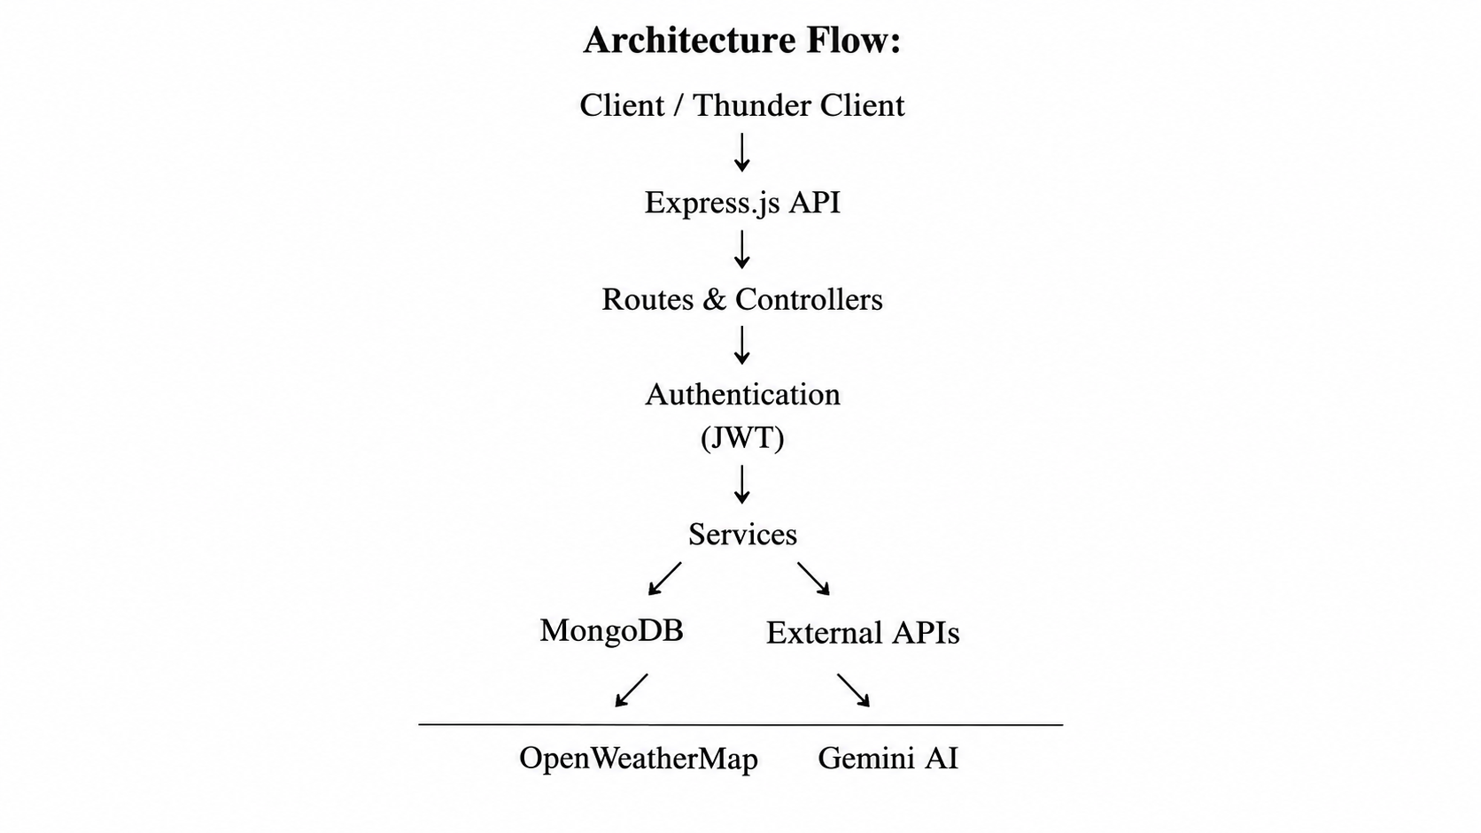

3. Database Documentation
MongoDB is used to store user and favourite location information. Mongoose is used to define schemas and communicate with MongoDB.
Main Entities:
USER
├── _id
├── name
├── email
├── password
└── role

LOCATION
├── _id
├── user
├── city
├── country
└── createdAt
Relationship: One User → Many Locations.

4. Main Modules
- Authentication Module: Handles registration, login, password hashing and JWT authentication.
- Location Module: Manages favourite locations.
- Weather Module: Retrieves current weather information using OpenWeatherMap.
- AI Service: Generates weather summaries, recommendations and chatbot responses.
- Database Module: Manages MongoDB operations using Mongoose.
- Middleware: Protects authenticated routes using JWT verification.

5. API Documentation
The major APIs implemented are:
API | Purpose
Register | Creates a new user
Login | Authenticates user and generates JWT
Weather | Retrieves current weather
Weather Summary | Generates AI weather summary
Recommendation | Generates weather recommendations
Locations | Manages favourite locations
AI Chat | Provides conversational weather assistance

6. Security and Error Handling
The application uses bcrypt for password hashing and JWT for authentication. Environment variables are used to store API keys and sensitive configuration values. Error handling is implemented for invalid requests and external service failures. A fallback response is provided when the Gemini AI service is unavailable.

7. Documentation Evidence
The documentation phase includes screenshots of:
- Project folder structure
- MongoDB connection
- Server execution
- User registration and login
- JWT authentication
- Weather API response
- AI summary and recommendation
- Favourite location API
- AI chatbot response
8. Outcome
The Project Documentation Phase provides a structured technical record of the AI WeatherWise application, including its architecture, database, APIs, security mechanisms and testing evidence. This documentation serves as a reference for understanding and maintaining the developed system.

